**VOKSELJET VX1000 3D SYSTEM** 1000 x 600 x 500 mm,

Manufacturer : Voxeljet AG / Made in Germany

Year Of Manufacture : 2020

Device Condition: Very good

Location: Istanbul - TURKİYE

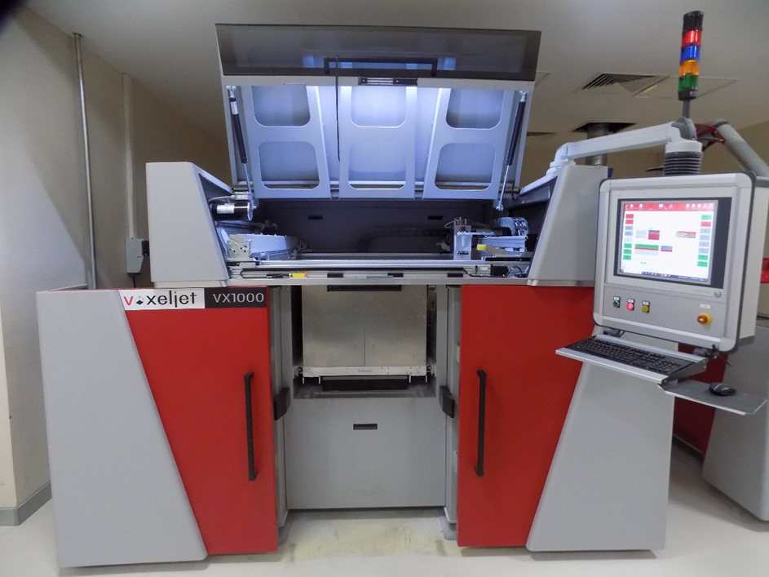

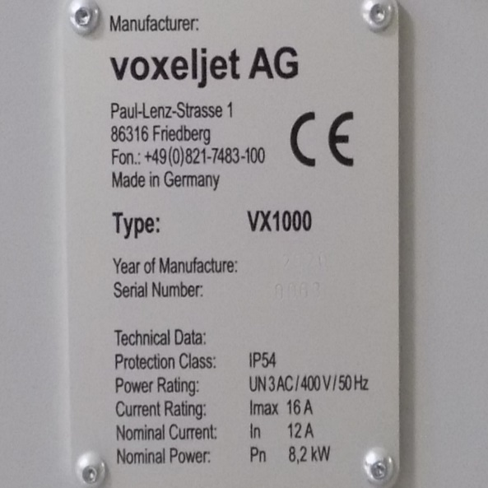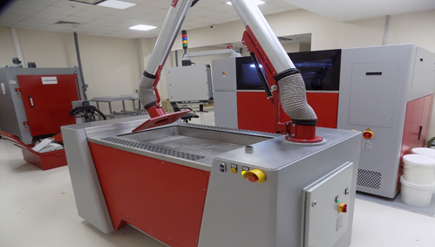

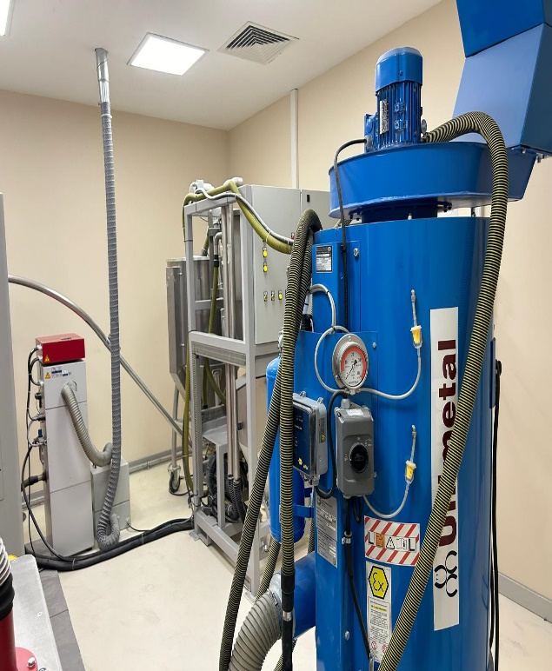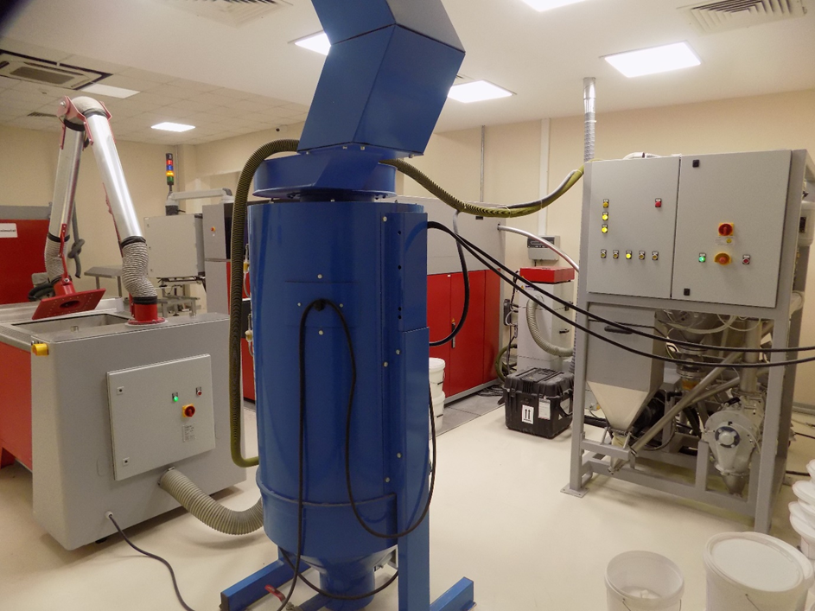

DUST SUCTION AND STORAGE UNIT

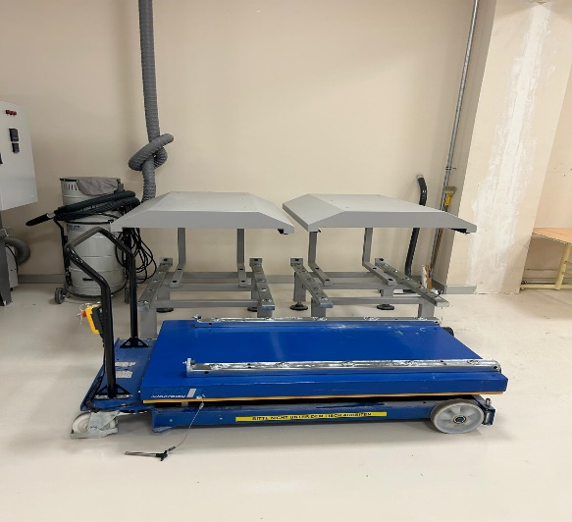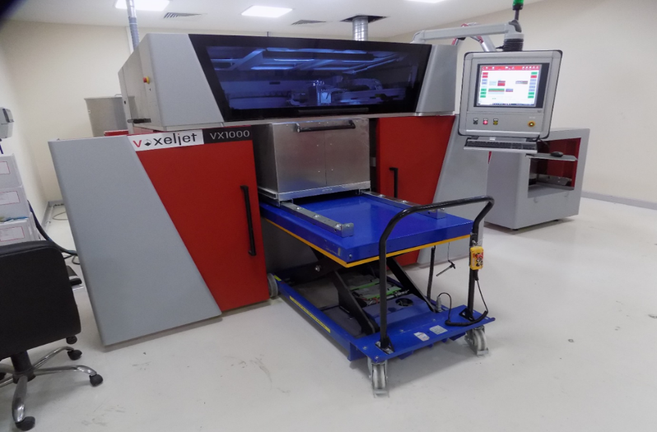

JOB BOX STATİON

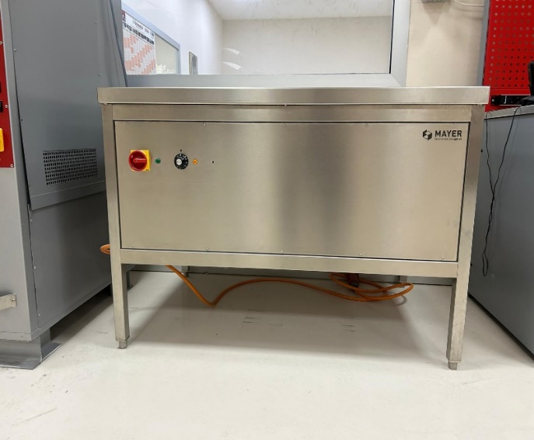

WAX STORAGE