Universal horizontal forging machine with vertical parting dies. Model В1141.
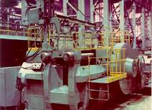  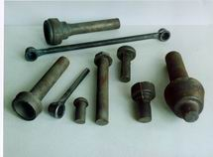  The machine is intended for hot forming of forgings from cut-to-length blanks or rods in multiple impression dies. The machines can be used for the following technological operations: upsetting, semi-piercing, piercing, reduction, cutting, bending.  The horizontal forging machine may operate in the following modes: single strokes, continuous strokes, set up. | Max. diameter of work piece, mm | 140
 | Max. diameter of upset flange, mm | 180
 | Upset slide nominal force, kN | 12500
 | Force on clamping slide with dies closed, kN | 12500
 | Upset slide stroke, mm | 460
 | Upset slide stroke with dies closed, mm | 310
 | Slide continuous idle strokes per minute, min | 32
 | Electric motor power, kW | 75
 | Machine overall dimensions, mm
 | length | 6400
 | width | 4360
 | height  Weight | 3760  135000

